**C – Sixth Sunday of Easter – May 25, 2025**

**Final Eastertide Sunday**

**17th Appearance near Jacob’s well at Sychar to Nalda and about 75 Samaritans on Saturday, May 13, 30 A.D. about 4 p.m.**

**18th Appearance at Tyre to the Phoenicians on Tuesday, May 16, 30 A.D. a little before 9 p.m.**

**and the Causes of Judas’s Downfall**

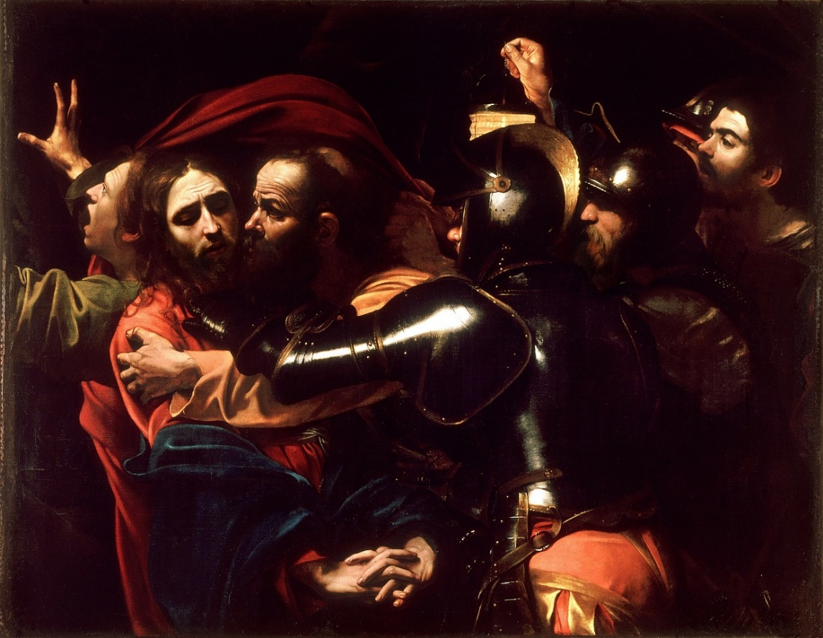

**Michaelangelo Merisi da Caravaggio (1571 – 1610) – The Taking of Jesus, 1602**

**Initial Reflection –** This famous Caravaggio painting know as “The Taking of Christ” dramatically portrays the horror of the moment and perfidy of Judas. As the shining armor of the arresting officer’s arm is said to serve as a mirror of self-reflection and examination of the viewer’s our own conscience, the Urantia gospel offers a reflection on Judas’s life and circumstances the led to his deceitful betrayal, giving us a chance to reflect on our own lives.

The first and second readings cover appearances to important gentile communities sympathetic to Jesus from his earlier work, before his final appearance to the apostles at his resurrection in Jerusalem from the Mount of Olives.

**Reading 1 –** **Urantia, Part IV. The Life and Teachings of Jesus, Paper 193 – Final Appearances and Ascension, Section 1. The Appearance at Sychar, Paragraphs 1 -3**

193:1.1 (2053.3) About four o’clock on Sabbath afternoon, May 13, the Master appeared to Nalda and about seventy-five Samaritan believers near Jacob’s well, at Sychar. The believers were in the habit of meeting at this place, near where Jesus had spoken to Nalda concerning the water of life. On this day, just as they had finished their discussions of the reported resurrection, Jesus suddenly appeared before them, saying:

193:1.2 (2053.4) “Peace be upon you. You rejoice to know that I am the resurrection and the life, but this will avail you nothing unless you are first born of the eternal spirit, thereby coming to possess, by faith, the gift of eternal life. If you are the faith sons of my Father, you shall never die; you shall not perish. The gospel of the kingdom has taught you that all men are the sons of God. And this good news concerning the love of the heavenly Father for his children on earth must be carried to all the world. The time has come when you worship God neither on Gerizim nor at Jerusalem, but where you are, as you are, in spirit and in truth. It is your faith that saves your souls. Salvation is the gift of God to all who believe they are his sons. But be not deceived; while salvation is the free gift of God and is bestowed upon all who accept it by faith, there follows the experience of bearing the fruits of this spirit life as it is lived in the flesh. The acceptance of the doctrine of the fatherhood of God implies that you also freely accept the associated truth of the brotherhood of man. And if man is your brother, he is even more than your neighbor, whom the Father requires you to love as yourself. Your brother, being of your own family, you will not only love with a family affection, but you will also serve as you would serve yourself. And you will thus love and serve your brother because you, being my brethren, have been thus loved and served by me. Go, then, into all the world telling this good news to all creatures of every race, tribe, and nation. My spirit shall go before you, and I will be with you always.”

193:1.3 (2054.1)These Samaritans were greatly astonished at this appearance of the Master, and they hastened off to the near-by towns and villages, where they published abroad the news that they had seen Jesus, and that he had talked to them. And this was the seventeenth morontia appearance of the Master.[1]

**Reflection -** This appearance is not even alluded to the Christian new testament yet is of great importance. Jesus tells this gentile group despised by the Jews to not just gather in his name and discuss his resurrection, but more importantly to be “born of the eternal spirit,” through personal faith, to possess the gift of eternal life for themselves. He emphasized the brotherhood of all humankind, and then boldly sent them forth, “Go, then, into all the world telling this good news to all creatures of every race, tribe, and nation. My spirit shall go before you, and I will be with you always.”

It is important to note that Jesus did not leave the Samaritans alone but sent them the Spirit of Truth, and the physical ministry of Philip.

**Responsorial Psalm -** [**Psalm 67:2-3, 5, 6, 8**](https://bible.usccb.org/bible/psalms/67?2) [2] **R (4)****“People pour out gratitude to you; people will pour out gratitude, all of them.”**

“God, treat us gently, and we will knell before you in praise. Light up your face so we can see it – Selah – to make your path known to the earth; your saving power to all the nations.”   
**R. “People pour out gratitude to you; people will pour out gratitude, all of them.”**

“Countries will rejoice, crying out with praise. For you judge all people with clarity; you guide all countries of the earth – Selah.”   
**R. “People pour out gratitude to you; people will pour out gratitude, all of them.”**

“People will pour out gratitude to you. People will pour out gratitude, all of them. The Creator, our God, has blessed us, and will continue to bless until the ends of the earth hold you in awe.”   
**R. “People pour out gratitude to you; people will pour out gratitude, all of them.” [3]**

**Reflection –** Both translations emphasize that God treats all nations, countries and peoples with clarity and equity, and guides them all. In the last line, Pamela Greenberg’s translation emphasizes awe rather than fear, which reflects a major difference in a person’s attitude toward God. This is much in keeping with the message of Jesus.

**Urantia, Part IV. The Life and Teachings of Jesus, Paper 193 – Final Appearances and Ascension, Section 2. The Phoenician Appearance, Paragraphs 1 - 3**

193:2.1 (2054.2) The Master’s eighteenth morontia appearance was at Tyre, on Tuesday, May 16, at a little before nine o’clock in the evening. Again he appeared at the close of a meeting of believers, as they were about to disperse, saying:

193:2.2 (2054.3) “Peace be upon you. You rejoice to know that the Son of Man has risen from the dead because you thereby know that you and your brethren shall also survive mortal death. But such survival is dependent on your having been previously born of the spirit of truth-seeking and God-finding. The bread of life and the water thereof are given only to those who hunger for truth and thirst for righteousness—for God. The fact that the dead rise is not the gospel of the kingdom. These great truths and these universe facts are all related to this gospel in that they are a part of the result of believing the good news and are embraced in the subsequent experience of those who, by faith, become, in deed and in truth, the everlasting sons of the eternal God. My Father sent me into the world to proclaim this salvation of sonship to all men. And so send I you abroad to preach this salvation of sonship. Salvation is the free gift of God, but those who are born of the spirit will immediately begin to show forth the fruits of the spirit in loving service to their fellow creatures. And the fruits of the divine spirit which are yielded in the lives of spirit-born and God-knowing mortals are: loving service, unselfish devotion, courageous loyalty, sincere fairness, enlightened honesty, undying hope, confiding trust, merciful ministry, unfailing goodness, forgiving tolerance, and enduring peace. If professed believers bear not these fruits of the divine spirit in their lives, they are dead; the Spirit of Truth is not in them; they are useless branches on the living vine, and they soon will be taken away. My Father requires of the children of faith that they bear much spirit fruit. If, therefore, you are not fruitful, he will dig about your roots and cut away your unfruitful branches. Increasingly, must you yield the fruits of the spirit as you progress heavenward in the kingdom of God. You may enter the kingdom as a child, but the Father requires that you grow up, by grace, to the full stature of spiritual adulthood. And when you go abroad to tell all nations the good news of this gospel, I will go before you, and my Spirit of Truth shall abide in your hearts. My peace I leave with you.”

193:2.3 (2054.4) And then the Master disappeared from their sight. The next day there went out from Tyre those who carried this story to Sidon and even to Antioch and Damascus. Jesus had been with these believers when he was in the flesh, and they were quick to recognize him when he began to teach them. While his friends could not readily recognize his morontia form when made visible, they were never slow to identify his personality when he spoke to them.[4]

**Reflection –** Like the Samaritans Jesus commissioned the Phoenicians and told them that when they “go abroad to tell all nations the good news of this gospel, I will go before you, and my Spirit of Truth shall abide in your hearts.” To his group of gentiles Jesus emphasized that the fruits of divine spirit are: “loving service, unselfish devotion, courageous loyalty, sincere fairness, enlightened honesty, undying hope, confiding trust, merciful ministry, unfailing goodness, forgiving tolerance, and enduring peace.”

**Alleluia -** [**John 14:23**](https://bible.usccb.org/bible/john/14?23) **R. Alleluia, alleluia.**

Whoever loves me will keep my word, says the Lord, and my Father will love him and we will come to him.  
**R. Alleluia, alleluia.[5]**

**Gospel - Urantia, Part IV. The Life and Teachings of Jesus, Paper 193 – Final Appearances and Ascension, Section 4. Causes of Judas’s Downfall 1 – 14**

193:4.1 (2055.4) It was in the first part of the Master’s farewell message to his apostles that he alluded to the loss of Judas and held up the tragic fate of their traitorous fellow worker as a solemn warning against the dangers of social and fraternal isolation. It may be helpful to believers, in this and in future ages, briefly to review the causes of Judas’s downfall in the light of the Master’s remarks and in view of the accumulated enlightenment of succeeding centuries.

193:4.2 (2055.5) As we look back upon this tragedy, we conceive that Judas went wrong, primarily, because he was very markedly an isolated personality, a personality shut in and away from ordinary social contacts. He persistently refused to confide in, or freely fraternize with, his fellow apostles. But his being an isolated type of personality would not, in and of itself, have wrought such mischief for Judas had it not been that he also failed to increase in love and grow in spiritual grace. And then, as if to make a bad matter worse, he persistently harbored grudges and fostered such psychologic enemies as revenge and the generalized craving to “get even” with somebody for all his disappointments.

193:4.3 (2056.1) This unfortunate combination of individual peculiarities and mental tendencies conspired to destroy a well-intentioned man who failed to subdue these evils by love, faith, and trust. That Judas need not have gone wrong is well proved by the cases of Thomas and Nathaniel, both of whom were cursed with this same sort of suspicion and overdevelopment of the individualistic tendency. Even Andrew and Matthew had many leanings in this direction; but all these men grew to love Jesus and their fellow apostles more, and not less, as time passed. They grew in grace and in a knowledge of the truth. They became increasingly more trustful of their brethren and slowly developed the ability to confide in their fellows. Judas persistently refused to confide in his brethren. When he was impelled, by the accumulation of his emotional conflicts, to seek relief in self-expression, he invariably sought the advice and received the unwise consolation of his unspiritual relatives or those chance acquaintances who were either indifferent, or actually hostile, to the welfare and progress of the spiritual realities of the heavenly kingdom, of which he was one of the twelve consecrated ambassadors on earth.

193:4.4 (2056.2) Judas met defeat in his battles of the earth struggle because of the following factors of personal tendencies and character weakness:

193:4.5 (2056.3) 1. He was an isolated type of human being. He was highly individualistic and chose to grow into a confirmed “shut-in” and unsociable sort of person.

193:4.6 (2056.4) 2. As a child, life had been made too easy for him. He bitterly resented thwarting. He always expected to win; he was a very poor loser.

193:4.7 (2056.5) 3. He never acquired a philosophic technique for meeting disappointment. Instead of accepting disappointments as a regular and commonplace feature of human existence, he unfailingly resorted to the practice of blaming someone in particular, or his associates as a group, for all his personal difficulties and disappointments.

193:4.8 (2056.6) 4. He was given to holding grudges; he was always entertaining the idea of revenge.

193:4.9 (2056.7) 5. He did not like to face facts frankly; he was dishonest in his attitude toward life situations.

193:4.10 (2056.8) 6. He disliked to discuss his personal problems with his immediate associates; he refused to talk over his difficulties with his real friends and those who truly loved him. In all the years of their association he never once went to the Master with a purely personal problem.

193:4.11 (2056.9) 7. He never learned that the real rewards for noble living are, after all, spiritual prizes, which are not always distributed during this one short life in the flesh.

193:4.12 (2056.10) As a result of his persistent isolation of personality, his griefs multiplied, his sorrows increased, his anxieties augmented, and his despair deepened almost beyond endurance.

193:4.13 (2057.1) While this self-centered and ultraindividualistic apostle had many psychic, emotional, and spiritual troubles, his main difficulties were: In personality, he was isolated. In mind, he was suspicious and vengeful. In temperament, he was surly and vindictive. Emotionally, he was loveless and unforgiving. Socially, he was unconfiding and almost wholly self-contained. In spirit, he became arrogant and selfishly ambitious. In life, he ignored those who loved him, and in death, he was friendless.

193:4.14 (2057.2) These, then, are the factors of mind and influences of evil which, taken altogether, explain why a well-meaning and otherwise onetime sincere believer in Jesus, even after several years of intimate association with his transforming personality, forsook his fellows, repudiated a sacred cause, renounced his holy calling, and betrayed his divine Master.[6]

**Reflection –** As we “are born of the spirit of truth-seeking and God-finding mortals” it is wise to consider factors that could uncut, impede or destroy our efforts.

1. **Replaced Reading 1** [**Acts 15:1-2, 22-29**](https://bible.usccb.org/bible/acts/15?1)

   Some who had come down from Judea were instructing the brothers, “Unless you are circumcised according to the Mosaic practice, you cannot be saved.” Because there arose no little dissension and debate by Paul and Barnabas with them, it was decided that Paul, Barnabas, and some of the others should go up to Jerusalem to the apostles and elders about this question.  
     
   The apostles and elders, in agreement with the whole church, decided to choose representatives and to send them to Antioch with Paul and Barnabas. The ones chosen were Judas, who was called Barsabbas, and Silas, leaders among the brothers. This is the letter delivered by them:  
     
   “The apostles and the elders, your brothers, to the brothers in Antioch, Syria, and Cilicia  
   of Gentile origin: greetings. Since we have heard that some of our number who went out without any mandate from us have upset you with their teachings and disturbed your peace of mind, we have with one accord decided to choose representatives and to send them to you along with our beloved Barnabas and Paul, who have dedicated their lives to the name of our Lord Jesus Christ. So we are sending Judas and Silas who will also convey this same message by word of mouth: ‘It is the decision of the Holy Spirit and of us not to place on you any burden beyond these necessities, namely, to abstain from meat sacrificed to idols, from blood, from meats of strangled animals, and from unlawful marriage. If you keep free of these, you will be doing what is right.  Farewell.’”
2. After and inspired by Pamela Greenberg’s **The Complete Psalms – The Book of Prayer Songs in a New Translation.**
3. **Replaced Responsorial Psalm -** [**Psalm 67:2-3, 5, 6, 8**](https://bible.usccb.org/bible/psalms/67?2)

   **R (4) O God, let all the nations praise you!**

   May God have pity on us and bless us; may he let his face shine upon us. So may your way be known upon earth; among all nations, your salvation.  
   **R. O God, let all the nations praise you!**

   May the nations be glad and exult because you rule the peoples in equity; the nations on the earth you guide.  
   **R. O God, let all the nations praise you!**  
     
   May the peoples praise you, O God; may all the peoples praise you! May God bless us, and may all the ends of the earth fear him!  
   **R. O God, let all the nations praise you!**  
   
4. **Replaced Reading 2 -** [**Revelation 21:10-14, 22-23**](https://bible.usccb.org/bible/revelation/21?10) - *When the Ascension of the Lord is celebrated the following Sunday, the second reading and Gospel from the Seventh Sunday of Easter may be read on the Sixth Sunday of Easter.*

   The angel took me in spirit to a great, high mountain and showed me the holy city Jerusalem coming down out of heaven from God. It gleamed with the splendor of God. Its radiance was like that of a precious stone, like jasper, clear as crystal. It had a massive, high wall, with twelve gates where twelve angels were stationed and on which names were inscribed, the names of the twelve tribes of the Israelites. There were three gates facing east, three north, three south, and three west. The wall of the city had twelve courses of stones as its foundation, on which were inscribed the twelve names of the twelve apostles of the Lamb.  
     
   I saw no temple in the city for its temple is the Lord God almighty and the Lamb. The city had no need of sun or moon to shine on it, for the glory of God gave it light, and its lamp was the Lamb.
5. **Replaced** **Alleluia -** [**John 14:23**](https://bible.usccb.org/bible/john/14?23) **R. Alleluia, alleluia.**

   Whoever loves me will keep my word, says the Lord, and my Father will love him and we will come to him.  
   **R. Alleluia, alleluia.**
6. **Replaced Gospel -** [**John 14:23-29**](https://bible.usccb.org/bible/john/14?23) *When the Ascension of the Lord is celebrated the following Sunday, the second reading and Gospel from the Seventh Sunday of Easter may be read on the Sixth Sunday of Easter.*

   Jesus said to his disciples: “Whoever loves me will keep my word, and my Father will love him, and we will come to him and make our dwelling with him. Whoever does not love me does not keep my words; yet the word you hear is not mine but that of the Father who sent me.  
     
   “I have told you this while I am with you. The Advocate, the Holy Spirit, whom the Father will send in my name, will teach you everything and remind you of all that I told you. Peace I leave with you; my peace I give to you. Not as the world gives do I give it to you. Do not let your hearts be troubled or afraid. You heard me tell you, ‘I am going away and I will come back to you.’ If you loved me, you would rejoice that I am going to the Father; for the Father is greater than I. And now I have told you this before it happens, so that when it happens you may believe.”